Fundamentals Of Data Science-DSA0410
Lab Experiments

D.Kesava Rao
192472389

Experiment-1
Program:
import pandas as pd
import numpy as np
df = pd.read_csv("student_scores.csv")
subjects = ["Math", "Science", "English", "History"]
scores = df[subjects]
student_scores = scores.to_numpy()
subject_averages = np.mean(student_scores, axis=0)
highest_subject = subjects[np.argmax(subject_averages)]
print("Subject-wise averages:")
for subject, avg in zip(subjects, subject_averages):
print(f"{subject}: {avg:.2f}")
print("\nSubject with highest average score:", highest_subject)
Output:
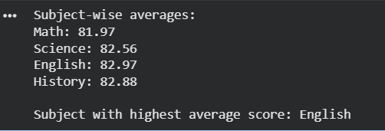

Experiment-2
Program:
import numpy as np
sales_data = np.array([
[200, 220, 210],
[150, 160, 170],
[300, 310, 320]
])
average_price = np.mean(sales_data)
print("Average price of products:", average_price)

Output:
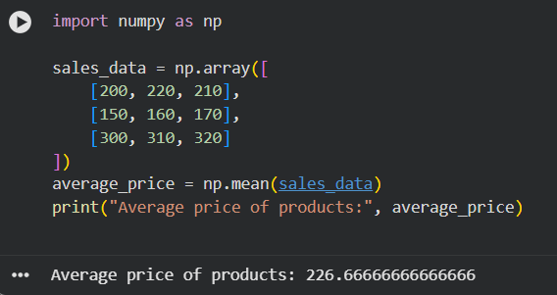

Experiment-3:
Program:
import numpy as np
house_data = np.array([
[3, 1200, 250000],
[5, 2000, 450000],
[4, 1500, 300000],
[6, 2500, 600000]
])
filtered_houses = house_data[house_data[:, 0] > 4]
average_price = np.mean(filtered_houses[:, 2])
print("Average sale price of houses with more than 4 bedrooms:", average_price)
Output:
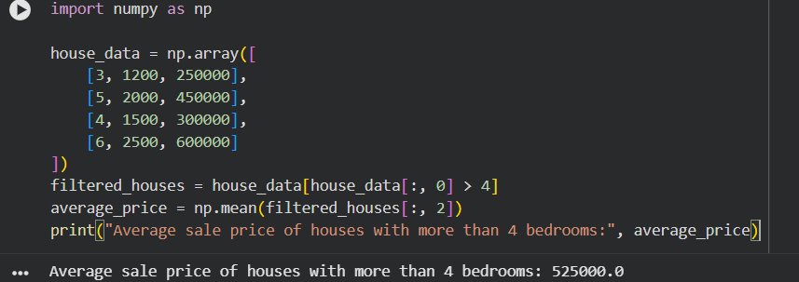

Experiment-4:
Program:
import numpy as np
sales_data = np.array([20000, 25000, 30000, 35000])
total_sales = np.sum(sales_data)
percentage_increase = ((sales_data[3] - sales_data[0]) / sales_data[0]) * 100
print("Total sales for the year:", total_sales)
print("Percentage increase from Q1 to Q4:", percentage_increase, "%")
Output:
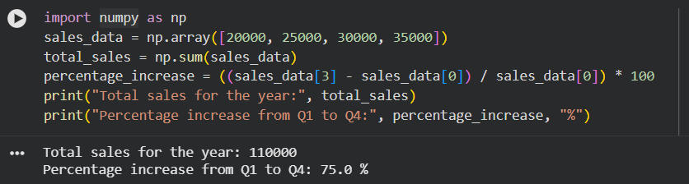

Experiment-5:
Program:
import numpy as np
fuel_efficiency = np.array([18, 22, 25, 28])
average_efficiency = np.mean(fuel_efficiency)
percentage_improvement = ((fuel_efficiency[3] - fuel_efficiency[0]) / fuel_efficiency[0]) * 100
print("Average fuel efficiency:", average_efficiency)
print("Percentage improvement:", percentage_improvement, "%")
Output:
